# Install Magento 2 with docker

1. Download Docker Desktop from [Click Here](https://www.docker.com/products/docker-desktop/).
2. Install docker desktop as administrator.

After installation, please restart the system and open docker after restart.

1. Now install **wsl_update_x64.msi.**
2. Open command prompt
3. Run wsl -l -o

This will give you the list of distribution versions that can be installed.

1. Run **wsl --list --verbose**

This will provide you the wsl integration distribution installed on system.

1. If Ubuntu is not installed run

**wsl --install -d Ubuntu-22.04**

1. Now you can check by **wsl –list --verbose**
2. Now open **Ubuntu-22.04** from search
3. Open ./bashrc

**nano ~/.bashrc**

1. Add below lines at the end of the file

#wsl2 configuration

alias docker=docker.exe

alias docker-compose=docker-compose.exe

alias xbdl=”cd /mnt/c/Users/<username>/Sites/local.xbdl.com”

1. Open **This PC -> Network -> For Public Network**
   1. **Set Network Discovery: OFF**
   2. **Set File and printer sharing: ON**
2. mkdir -p /mnt/c/Users/<username>/Sites/local.xbdl.com
3. cd /mnt/c/Users/<username>/Sites/local.xbdl.com
4. curl -s https://raw.githubusercontent.com/markshust/docker-magento/master/lib/template | bash
5. git clone <https://msftdevicespartners.visualstudio.com/Montebello/_git/Montebello> src
6. cp -R ../xbdl/app/etc/env.php src/app/etc
7. bin/start --no-dev
8. bin/copytocontainer --all
9. bin/mysql < ../xbdl/stage.sql
10. bin/magento app:config:import
11. bin/setup-domain local.xbdl.com
12. bin/restart
13. bin/cli bash
14. ls -la ~ | more (if no .bashrc file exit run touch ~/.bashrc)
15. curl -o- <https://raw.githubusercontent.com/nvm-sh/nvm/v0.39.3/install.sh>
16. curl -o- https://raw.githubusercontent.com/nvm-sh/nvm/v0.39.3/install.sh | bash
17. source ~/.bashrc
18. nvm list-remote

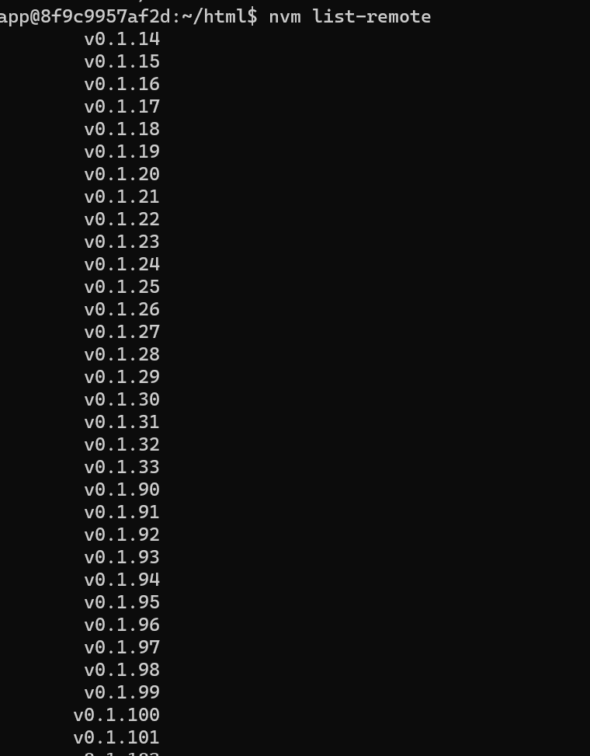

1. nvm install 12.13.0
2. nvm use 12
3. npm --prefix vendor/gorilla/m2-frontend-tools/ i
4. npm --prefix vendor/gorilla/m2-frontend-tools/ run setup
5. exit
6. bin/magento s:up
7. bin/magento s:d:c
8. bin/magento s:s:d en_US -f (for US store)
9. npm --prefix vendor/gorilla/m2-frontend-tools/ run styles
10. bin/magento c:f
11. Open local.xbdl.com